# ClubUML Spring 2014 Sprint 1 2/5/2014

# Topic: Form Validation – Register.jsp Name: Ameya Joshi

The objective for the second week of Sprint 1 was to finish the validation work on **index.jsp**, **register.jsp**. The validation work of **display.jsp** and other pages would be undertaken in Sprint 2. The features that have been added so far to the existing project are:

**Index.jsp**:

* A check on the login page (index.jsp) to check if the user is passing empty fields (null values) to the server. This check is done using JavaScript and not sent over to the server which would prevent unnecessary server load.
* A check on both the username and password field to see if they fit into the required conditions, i.e., the length of the password, use of limited special characters and no use of special characters in the username. This would be a preventive measure against SQL Injections.

**Register.jsp**:

* A check to validate if the username already exists on the system. This is done using a servlet.
* Constraints on the username to check that the username begins with a character and consists of characters, numbers and underscore only. This would be an added measure to prevent SQL Injections.
* Constraints on password to check that the password consists of characters, numbers and special characters like !, @, #, $, %, ^, &, *, (, ), _ only. This would be an added measure to prevent SQL Injections.
* A check to validate the email id, i.e., to check if that email id has already been used to create an account on the system. We will allow only one account to be created using one email id.
* A check to validate the format of the email id, i.e., the user has not entered an invalid format by mistake.

**Screenshots:**

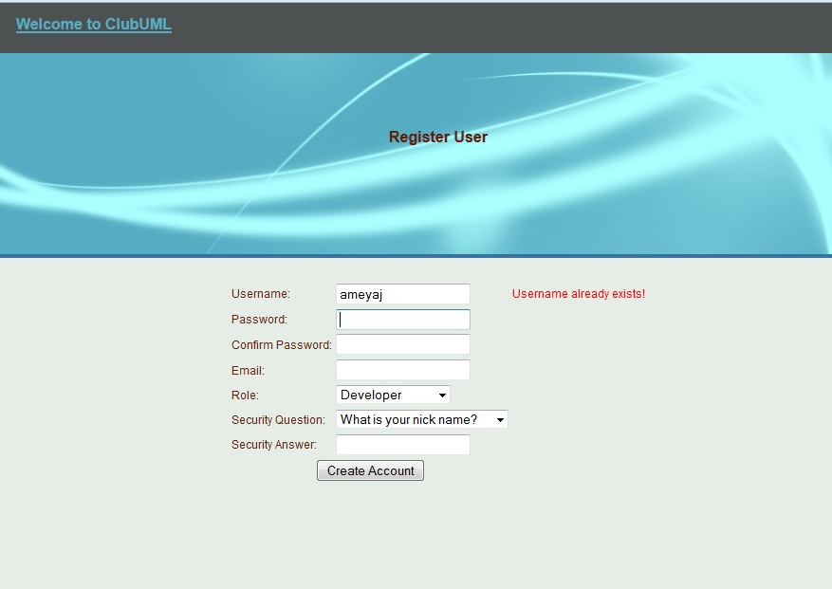

1. **Username already exists in the database check.**

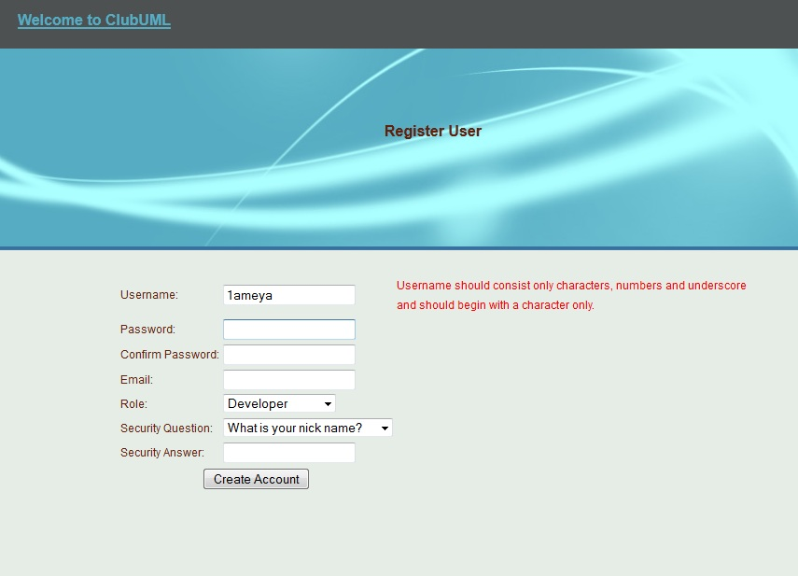

1. **Username character check**

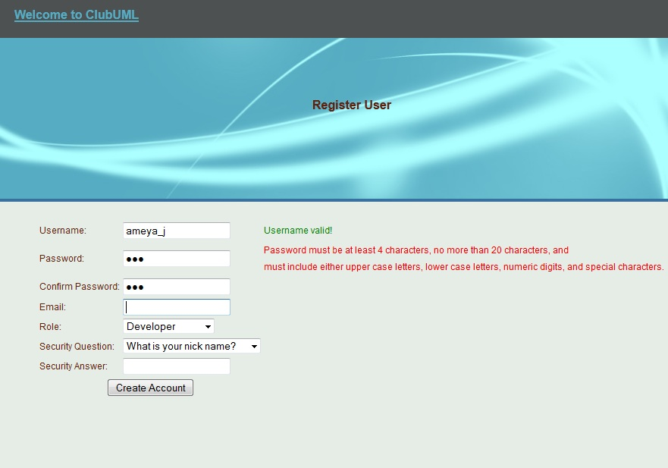

1. **Password character check**

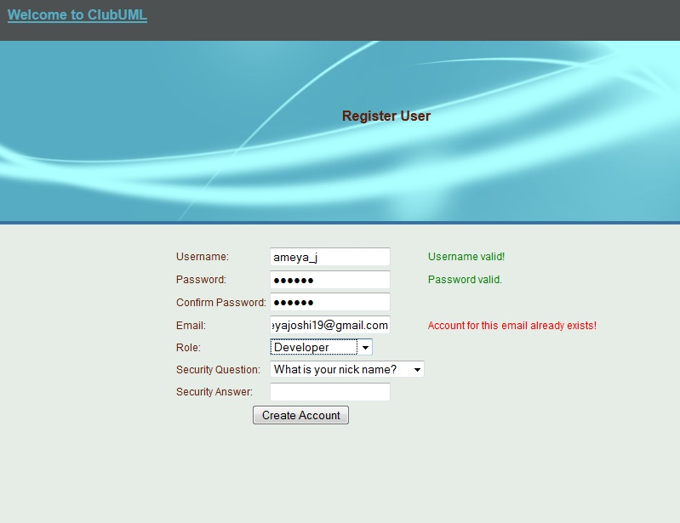

1. **Email already in database check**

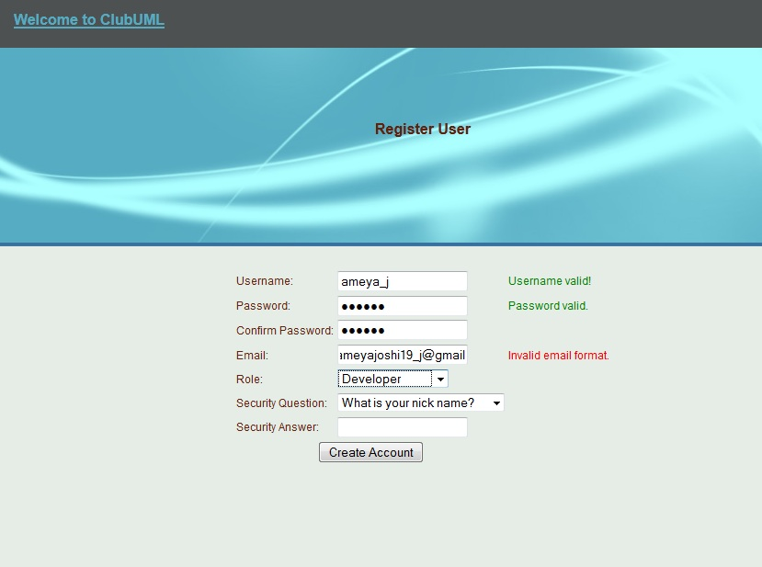

1. **Email format validation check**

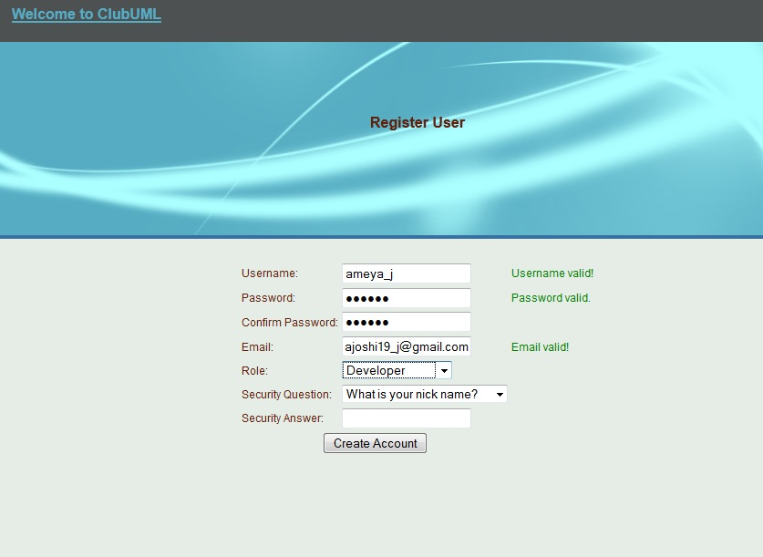

1. **Valid email format.**

**Plan of Action:**

The next page to be taken into consideration for validation would be:

* display.jsp
* managePolicy.jsp
* manageContext.jsp
* manageProject.jsp
* manageRelation.jsp